Building Specific Information
Building Name
Department Name
Department Head | Name: | Phone:
Nurse Manager | Name: | Phone:
Safety Representative | Name: | Phone
Alternate Safety Rep | Name: | Phone:

Fire Safety & Evacuation
Note: It is ECU Policy to immediately evacuate the building during a fire alarm. Do not re-enter the building until given the “All Clear” by emergency personnel.
Does the building have a fire alarm system?  Yes No | If no, please describe notification method:
Alternate notification method: | * Note: All buildings must have an alternate notification method, including those with fire alarm systems

Evacuation Assembly Points
When the alarm sounds, all occupants within the building must evacuate and report to an assigned evacuation assembly point. Do not use elevators. Assembly points should be away from traffic and parking lots and at least 100 paces from the building.
Primary Assembly Point:
Secondary Assembly Point:
How will clinic staff and patients be accounted for at the assembly point?

Building Specific Hazards
For example: stoves, chemical storage, compressed gas, dangerous equipment, etc.
Hazard | Location (Room #)

Areas of Rescue Assistance
Upon activation of the fire alarm, individuals who may require assistance during a building evacuation will immediately go to the building’s designated Area of Rescue Assistance. An Area of Rescue Assistance is a “safe” location with fire-resistant walls (an enclosed fire rated stairwell is a good example since they are required to have a higher fire rating than regular walls) where individuals can wait until rescue personnel arrive who cannot traverse the stairs without assistance . These areas are required on each floor above and below the “ground” floor. Upon activation of the fire alarm, individuals who may require assistance during a building evacuation will immediately go to the building’s designated Area of Rescue Assistance.

If you must go to an Area of Rescue, please use the LiveSafe app to contact ECU PD. By using LiveSafe, you can pick one of 3 options: Off-Campus: Call 911; On-Campus: Call ECU Police; or if can’t speak, then: Message ECU Police. When you pick an option, you will have direct contact with police. If LiveSafe is not available, then call ECU PD at 328-0062 for assistance.
The following areas are identified as Areas of Rescue Assistance:
Floor # | Area of Rescue Assistance

Defend in Place
If patients are located in a critical care area or are non-ambulatory during a fire, an employee will remain and initiate a “defend in place” strategy. The initial step should be closing the patient room and other room doors. Seal cracks and vents with towels or sheets (wet, if possible) to prevent smoke from entering the room. Signal for help (if possible) by hanging an object out of the window, such as a towel or jacket, to attract attention. If possible, call 9-1-1 to report the emergency, being sure to give your name, building, and specific location inside the building. If the fire moves beyond the patient room, horizontal evacuation should be initiated to closest stairwell. If the fire moves beyond the compartment, vertical evacuation should be initiated. The final step is facility evacuation.
How will emergency responders be notified of critical care areas?
How will communication be kept with staff remaining in critical care areas?
Floor # | Critical Care Location

Familiarization
Become familiar with the floor plan for the building and know the location of manual pull stations, fire extinguishers, telephones, exit routes, and exit doors. Remember: Do not use the elevator!

Employee Responsibilities & Procedures for Fire Safety & Evacuation
All ECU employees and students are expected to assist with and encourage complete building evacuation each time the fire alarm is activated. At no time, is any member of the University community required or expected to place themselves in a position that will compromise his or her safety. If fire or smoke conditions are encountered, you MUST leave the building immediately.
Employee Responsibilities & Procedures
Examples: secure vital documents, cash drawers, or any hazards under your control, close doors to contain smoke and fire, evacuate patients and visitors, etc.
A staff member should remain with evacuated patients and visitors at all times.

Shelter-in-Place
- Shelter-in-place procedures are actions taken to seek immediate shelter indoors when emergency conditions do not warrant or allow evacuation, such as for severe weather or hazardous material incident. If outside, move quickly to the closest building and follow the steps below for sheltering inside, or respond to directives provided by emergency personnel on the scene.
- If inside, stay indoors. Locate an interior room at ground level, with minimal windows. Close windows and exterior doors.
Notification may come from the ECU Alert System, ECU Police or other authorities.
In most cases, you should use your designated safe rooms to also shelter-in-place, however, there are exceptional cases such as influx of occupants in the building, a patient may not be able to move, or you may not have enough lead time to move everyone to the designated locations. If you and the occupants cannot get to a safe room, you should take place in a storm refuge area (see below).

Tornado / Storm Refuge Areas
Storm refuge areas are interior rooms or hallways without windows or hazardous chemicals / equipment located in the basement or lowest level(s) of a building. Occupants should stay in the center of the room or hallway, avoiding doors, windows, and exterior walls. If the situation allows, individuals should gather in one of the safe rooms (see the next page) or in an area listed below:

Lockdown
A lockdown is an emergency protocol used to protect people inside a facility from a dangerous internal or external threat. A lockdown means that people must lockdown to stay safe. See “Communication Plan.”
Immediately notify police of any potential, imminent, or present threat:

- Pitt County Dispatch: 9-1-1 from cell phone
- ECU Police: 9-1-1 from any campus phone
- ECU Police: 328-6150 (Main Campus)

Exterior
Can the building exterior be locked remotely by OneCard? Yes No
If not, who can lock exterior doors when safe to do so?

How many exterior doors to the building?

Interior
Can the interior doors be locked? Yes No Some
If so, how (latch / keys)? If key is required, who has keys?

Which rooms can be locked from inside?

Safe Rooms
Safe rooms are interior rooms without windows or hazardous chemicals / equipment and can be locked from inside. Safe rooms should be identified by the department and use a uniform marking. If the situation allows, individuals should gather in one of the following safe rooms:
Marking Used for Safe Rooms:

Safe Rooms:

Please contact ECU Police Department to schedule training in critical incident response. For example, hostile intruders, active shooters, bomb threats, etc.

Communication Plan
A plan should be developed to ensure all employees are made aware of any hazards that may endanger employees, patients, and visitors. All employees are encouraged to sign up for ECU Alert SMS text messages at www.ecu.edu/alert. ECU Alert is a collection of communication tools the University uses to distribute emergency notifications and information. It is only used for emergencies and occasional required testing. Emergency messages are also send through the LiveSafe app.
Where appropriate, in-depth information will be shown in a red bar on the ECU homepage at ecu.edu.

Form 33
Some situations may call for a more discreet method to call for help. ECU Police has designated the phase “form 33” to mean that an emergency is taking place or a situation is escalating, to be used when you are unable to discuss the circumstances at that time.
Instructions for use: Call 328-6150 and ask for a form 33. ECU Police may ask other questions that you can respond to with simple answers (i.e., yes or no, 1 or 2).

MS Lync
ECU Physicians utilizes Microsoft Lync, an instant messaging tool, to communicate within a clinic or nearby clinics. During an emergency situation, an employee may send a message to the designated clinic group saved in Lync to convey messages to all employees.
Instructions for use: Pull up Lync, right click the group you need to communicate with, click “Send an IM” and begin typing the situation or instruction. Press the red exclamation mark in the bottom right-hand corner (denoting high importance). Press enter to send the message. Follow internal procedures for the specific incident (i.e., lockdown, shelter-in-place, evacuation).

Paging System
ECU Physicians utilizes a paging system to communicate within a clinic. During an emergency situation, an employee may announce a code word or phrase to convey messages to all employees.
Instructions for use: Enter instructions.

Code Word / Phrases
In an emergency, it is best to use plain language to make sure everyone can understand the message. Some instances should be more discreet and may call for code words or phrases. These code words / phrases may be used on MS Lync or the paging system.
Code Word / Phrases: Enter clinic-specific code words and phrases.
See page 9 for additional information on ECU Alert and helpful contacts / resources.

Building Map(s)
Emergency Floor Plan required for clinics- with all listed items in Legend below included: Post in hallways where exits are not easily seen.

{Enter Clinic Name}
Insert Clinic Floor Plan(s)
Copy and paste icons from legend (below) to appropriate areas on inserted floor plans
Legend:
 | Evacuation Assembly Area — Location where evacuees convene once ordered to evacuate
 | Exit — Designated route out of the building
 | Area of Rescue Assistance — Area where people can go to await assistance if unable to evacuate for floors above and below ground floor
 | Storm Refuge Area — Specific locations that provide reasonable protection from severe weather
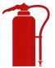 | Fire Extinguisher – Location of fire extinguisher(s)
 | Primary and Secondary Evacuation Routes
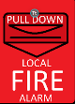 | Manual Fire Alarm Pull Station
 | Fire Alarm (Annunciator) Panel

Reference Material
RACE: Method of Evacuation
R Rescue and remove all persons in danger to a safe area
A Alert by pulling an Alarm, dialing 911, and communicate the danger to others
C Contain the fire by closing windows and doors
E Evacuate/Extinguish if trained and confident
If the fire alarm system is activated or you detect fire or smoke:
- Immediately evacuate the building using the nearest available exit. Do not attempt to fight a fire unless you have received the appropriate training.
- Sound the alarm as you leave the building by activating the pull station. Close doors as you exit.
- Call 911 from a safe location outside the building. Provide emergency personnel with specific information including your name, location of the incident, and nature of the emergency.
- Know an alternate exit route in case the primary exit is blocked.
- Do not use elevators. Feel doors before opening them. If they are hot, do not open them.
- If possible, secure vital documents, cash drawers, or any hazards under your control.
- If you get caught in smoke, get down and crawl, as cleaner, cooler air will be near the floor.
- Assemble at designated location and account for all personnel. No one should leave the area unless they are accounted for and the department safety representative or other response personnel know that they are leaving.
- Provide information to safety representative regarding missing and/or disabled persons. They will in turn provide information to the emergency response personnel.
Evacuation procedure for functional needs occupants:
- Persons with mobility impairments should go the nearest approved stairwell or Area of Rescue Assistance and wait for emergency personnel.
- If unable to go to the stairwell due to smoke, fire, or otherwise, occupants should stay in their room / office and follow the steps below…
If unable to exit:
- Keep doors closed.
- Seal cracks and vents with towels or sheets (wet, if possible) to prevent smoke from entering the room.
- Signal for help by hanging an object out of the window, such as a towel or jacket, to attract attention.
- If possible, call 911 to report the emergency, being sure to give your name, building, and specific location inside the building.
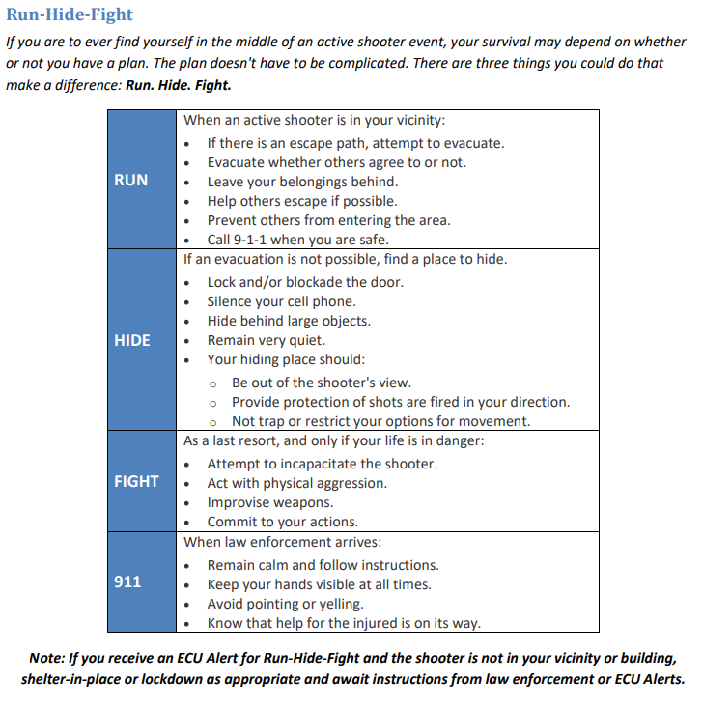

Shelter-in-Place Recommendations: Weather
A severe weather event such as a tornado, derecho (straight-line wind) event, or thunderstorm during normal operating hours of the University may necessitate you to shelter-in-place until the threat of bad weather has passed. Please review the following guidelines for sheltering in place for weather emergencies:
Tornado / Derecho
- Go to your designated storm refuge areas or safe rooms
- Stay in the center of the storm refuge area, away from doors and windows
- Protect your head and neck by taking the tornado safety position, if possible
- Stay in place until you receive of an all clear through ECU Alert
Thunderstorm & Lightning
- Stand or sit away from exterior doors and windows; do not lean, sit, or lie on concrete walls or floors
- Avoid contact with corded phones and devices; cordless and wireless phones and devices are OK to use
- Avoid contact with electrical equipment or cords; unplug appliances and other electrical items
- Avoid contact with plumbing; plumbing and bathroom fixtures can conduct electricity

Shelter-in-Place Recommendations: Hazardous Materials Incident
In the event of a critical incident where hazardous materials (including chemical, biological, or radiological) may have been released into the atmosphere either accidentally or intentionally, a decision to shelter-in-place may be the preferred method of safely waiting out the release/spill. The following recommendations should be considered:
- Close and lock all exterior doors; close vents and as many interior doors as possible
- Move to your safe rooms with no windows or hazardous equipment/materials
- Rooms that have little or no ventilation are preferred
  - If possible, turn off air conditioners and ventilation systems or set ventilation systems to 100% recirculation so that no outside air is drawn into the building
- Try to seal gaps under doorways and windows with towels
- Only leave your space or building when you are told that it is safe to do so through ECU Alert or by University Police

Emergency Notification System: ECU Alert
ECU Alert is a collection of communication tools the University uses to distribute emergency notifications and information. It is only used for emergencies and occasional required testing. It allows the University to send emergency messages through any of the following mechanisms:

- ECU Alert Web Page (www.ecu.edu/alert)
- ECU Pirate Email
- Text Messages
- PC Pop-up Notification
- ECU Hotline (252-328-0062)
- ECU Physicians Hotline (252-744-5080)
- Indoor / Outdoor Speakers
- VOIP Phones
- Digital LCD / Plasma Screens
- Twitter (@ecuAlert) & Facebook (ECU)

Other emergency notification systems may include NOAA Weather Radios, WITN 7, WNCT 9, WCTI 12, and local radio stations. Visit www.ecu.edu/alert for more information.
For assistance with:
Fire Evacuation and Shelter-in-Place contact EH&S; Lockdown contact ECU Police

Helpful Contacts & Resources
Should you have any questions or concerns, the following contacts may be of assistance to you and your unit:

- University Police | 328-6787 / 328-6150  TTY: 328-4827 | Home | Police | ECU
- Environmental Health & Safety | 328-6166 | Welcome | Office of Environmental Health and Safety | ECU
- Prospective Health | 744-2070 | Welcome to the Office of Prospective Health | Prospective Health | ECU
- Facilities Services | 328-6776 (E)  744-2251 (W) | Home | Facilities Services | ECU
- ECU Cares | 737-5555 | ECU CARES | ECU CARES | ECU
- ECU Information Line | 328-0062 | ECU Alerts | East Carolina University
- ECU Physicians Hotline | 744-5080 / 800-745-5181 | Home | ECU Physicians | ECU
- News Services | 328-6481 | News Services | News Services | ECU
- Student Health Services | 382-6841 | Welcome to Student Health Services | SHS | ECU
- Counseling & Student Development | 328-6661 | Counseling Service Options for ECU Students | Counseling Center | ECU
- Victim Services | 737-1466 | ECU Advocacy | Office of the Dean of Students | ECU
- Greenville Fire & Rescue | 329-4390 | Fire/Rescue | Greenville, NC (greenvillenc.gov)
- Greenville Police | 329-4315 | Police | Greenville, NC (greenvillenc.gov)
- Vidant Health | 847-4100 | Vidant Health | Eastern NC Health Care | Find a Doctor

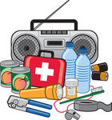
Pirates: Are YOU Ready?
Emergency preparedness is ultimately the responsibility of every faculty, staff, student, and visitor at East Carolina University. Knowing what to do before, during, and after an emergency is a critical part of being prepared and may make all the difference when seconds count. Every occupant of a building should prepare for emergencies and disasters through the following methods:
- Sign up for the campus' emergency notification system called ECU Alert at: http://www.ecu.edu/alert/

- Keep a Quick Reference Guide near your workspace. If you do not have one, download at: Severe-Weather-Procedures-Checklist-3-2019-2.pdf (ecu.edu)

- Like ECU News Services and East Carolina University on Facebook

- Follow ECU Alert (@ecuAlert), ECU Police (@ECUPolice) and ECU News Services (@ECUNewsServices) on Twitter

- Take the time to visit the ECU Police Department’s website at: http://www.ecu.edu/police/ as well as the ECU Alert webpage at: http://www.ecu.edu/alert and educate yourself on the resources available to you

- Download the LiveSafe app at www.ecu.edu/livesafe

- Make plans and preparations before an incident occurs

- Use the "buddy system" when planning for emergency response actions

- Keep your work area(s) clean and free of debris and other combustible materials

- Become familiar with your work area(s) and building. Pay attention to the location of evacuation maps (if available), fire extinguishers, fire alarm pull stations, and other fire and life safety equipment in the building

- Recognize potential hazards and report them immediately

- Remain aware of your surroundings and immediately call 911 to report suspicious persons or activities

- Actively participate in safety training (mandatory and non-mandatory), including but not limited to fire extinguisher training, fire evacuation drills, first aid training and self-defense training

- Annually review the building emergency action plan and make recommendations for improvement

- Create a preparedness kit to keep in or near your workspace; for more information visit http://ready.gov/

