Laboratory Incident Investigation Form
The purpose of an Incident Investigation form is to identify, address, and implement the corrective actions necessary to prevent future incidents from occurring. Most importantly, it is our core responsibility to maintain the well-being of staff, faculty, and students.
Incident Reporting Date: ________________ Incident Reporting Time: _____________
Section A Employee Information
Name: (Last, First)

Department: | Office:
Job Title:

Work Phone: | Email:
Supervisor Name: (Last, First)

Job Title: | Office:
Work Phone: | Email:
Section B Incident Description:
Date of Incident: |  | Time of Incident:
Location incident occurred:

Did any injuries occur? YES/NO If yes, be sure to complete Section D.

Materials, chemicals, substances being handled: (If chemicals, list chemical, concentration, and hazard information for each chemical involved and attach SDS.)

Was PPE in use during procedure? YES/NO If so, list specific PPE.

Please provide brief detailed description of incident:

Describe activity preceding incident (please include names of tools, materials, equipment, machines and other details):

Were lab personnel trained on Chemical Hygiene/Lab Safety? YES/NO
Was lab specific training conducted and signed by personnel for this procedure/protocol? YES/NO
Was there a lab safety plan in place? YES/NO If yes, attach to this form.
Was this a first-time procedure/protocol? YES/NO If yes, were you being supervised? YES/NO
Were there any witnesses present? YES/NO If YES, list name and contact information. Provide a detailed description on a separate document and attach to this form.

1.
2.
3.
Section C Why did the Incident Occur?
Unsafe Workplace Conditions: (Please check all that apply)  - Unguarded equipment  - Defective safety device(s)  - Defective equipment or tools  - Lack of appropriate equipment or tools  - Workstation layout  - Inadequate lighting  - Inadequate ventilation  - Insufficient PPE  - Insufficient training  - Other:_____________________ |  | Unsafe acts done by individuals: (Please check all that apply)  - Operating without permission  - Operating without training  - Servicing energized equipment  - Using defective equipment  - Using equipment inappropriately  - Unsafe lifting/pulling/pushing/reaching  - Distraction  - Wearing inappropriate clothing  - Failure to use proper tools and or equipment  - Other:_____________________
Are there underlying pressures that may cause lack of focus/attention? (Submission deadlines, etc…)

Have there been similar incidents prior to this one?

Section D Injured Person
Part of body affected: (identify all areas affected)  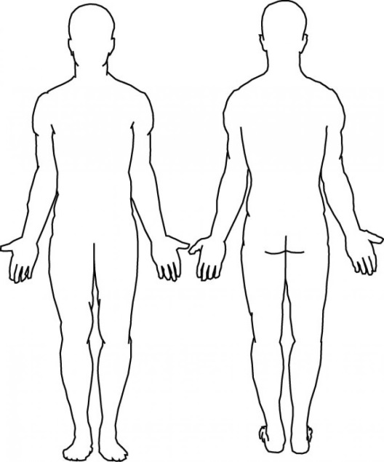 |  |  | Nature of injury: (mark all that apply)  - Abrasion  - Amputation  - Damage to eye  - Fracture  - Bruise  - Burn  - Concussion  - Crushing injury  - Cut/ laceration  - Hernia  - Needle sticks  - Sickness (nausea, headache, dizziness)  - Sprain  - Strain  - Damage to a body system  - Other:______________
Section E How Can This Be Avoided in the future?
What preventative measures can be practiced to avoid future occurrences?

- Discontinue Activity
- Train employees
- Train supervisors
- Redesign workstation
- Redesign task/process
- Routinely inspect for hazard
- Enforce existing policy
- Closer supervision
- Other:___________________

Section F Follow-up Training
How will you go about conducting follow-up training to prevent this occurrence from happening again in the future?

Section G Implementation Details
Person Responsible of Corrective Action | Action Taken | Date Implemented | Review Date

____________________________ ___________________
Employee Signature: Date:

____________________________ ___________________
Supervisor Signature: Date:

____________________________ ___________________
Investigator Signature: Date:

Attachments: Photos, drawing etc.

