**Using the Onsite System: PI and Lab Staff**

**Last Review: September 2021  
Reviewer: JU  
Related Policies & Resources:** Chemical Hygiene Plan, Laboratory Safety Compliance, OSHA  
**Contact for Info:** Lab Safety Specialist or Health Sciences Coordinator, 328-6166

1. **Introduction** 
   1. Starting in late 2020, the ECU Onsite System will be utilized to manage chemical inventories, request waste pick-up, manage lab and worker information, and other relevant tasks. The system allows for an interactive space for labs and clinics to respond to deficiencies found during EH&S inspections. All authorized lab personnel are required to take chemical hygiene/lab safety training. This training is offered in person as well as online. Training will be recorded in the Onsite system.
   2. Log into the Onsite system. <https://onsite.ecu.edu/ehsa/>
   3. Reference links concerning U.S. EPA, OSHA, and SDS information are available on the Onsite home page.
2. **Worker Registration/ view training records**
   1. Select “***Worker Registration***” on the home screen. To see a list of workers attached to a PI, select the PI from the drop-down “workers attached to”.

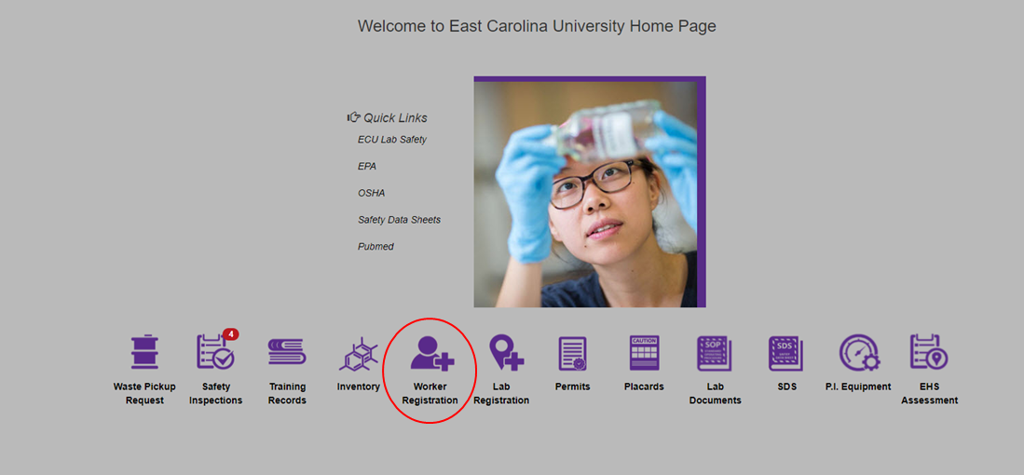

* + 1. Remove an employee: click on the red “Remove from Permit” button. Button will turn grey and read “Pending Removal.” EH&S will receive a request notification and approve/deny the removal to complete the action.
    2. Add an employee: click “Add New Worker” top-left in the “Pending Registrations box.” Fill out required fields with an asterisk, ensuring worker type says “*lab worker*” (even if the individual is a PI- they can be changed to a PI at a later step by EH&S). Click “Save”. The employee will then show up under the “Pending Registrations” box. Once reviewed by EH&S, the name will be moved from the Pending Box to the box below for Attached Workers.
  1. Review training records and requirements: select the “***Training Records***” icon. All employees attached to the PI permit will show up on the left side of the screen.
  2. Click to highlight each employee individually to view their records. The top box on the right shows requirements for the employee as well as fulfillment status. It also shows training type and due dates and how frequent the course is required.
  3. To print or view an overview of records and training due for all of your employees, click on the “Training Reports” drop down menu at the top left of the page. Use the first report, “Training Due by P.I. group.” Be sure pop-up blockers don’t prevent the pdf report from loading.

1. **New Lab Registration**
   1. Set up room/attach to PI: click the ***Lab Registration*** icon on the home screen.

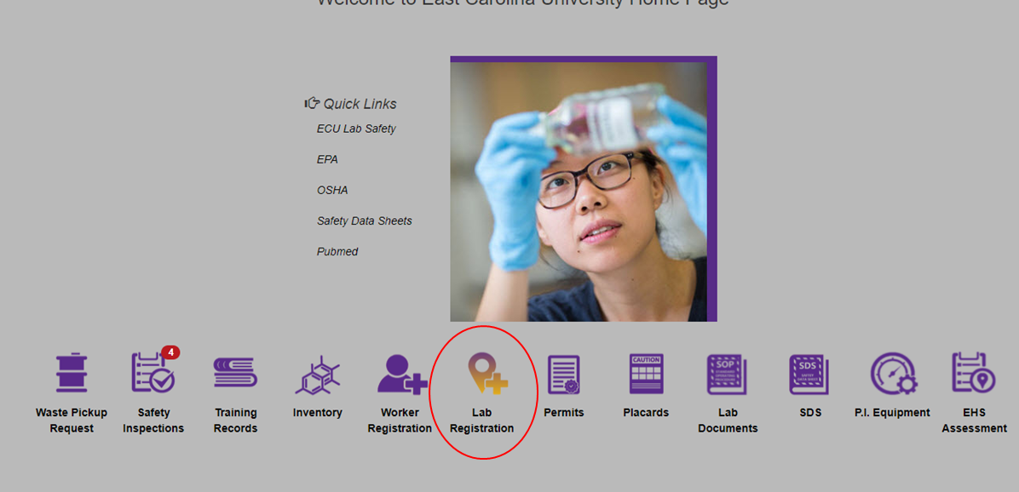

* 1. Ensure the correct PI name is populated in the *Researcher* field at the top-left. A list of lab locations attached to the PI/permit will be listed below. To remove one, simply click the red “Request Removal” button, and confirm when prompted to do so. EH&S will receive a notification of this request and complete or deny the change for it to take effect.

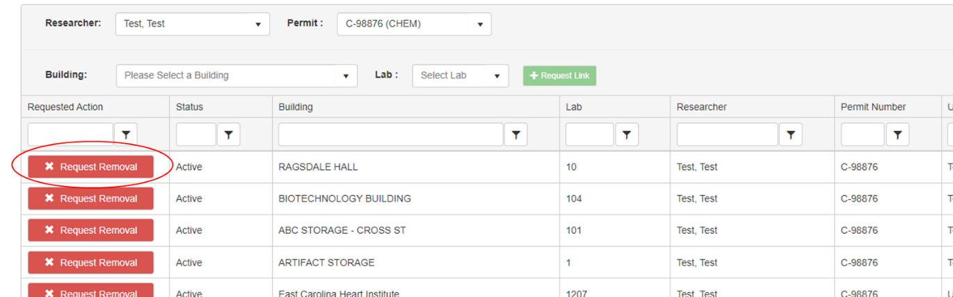

* 1. Add a new location: search for a *building* in the drop-down and then the corresponding *lab room* in the subsequent drop-down.
  2. Click the green “***Request link****”* button.A notification will be sent to EH&S, who will complete or deny the request.

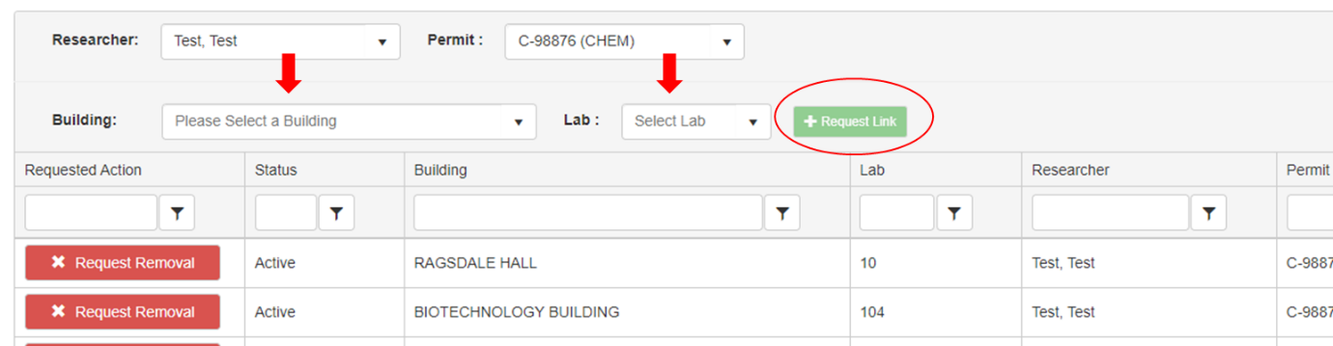

1. **SDS Search**
   1. To search for the SDS for a specific chemical, first click the **SDS** icon on the home screen.

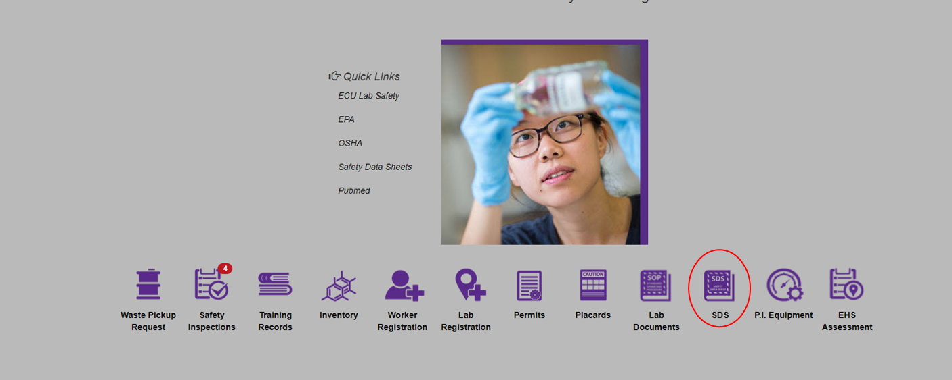

* 1. Select the appropriate choice in the “search” box on the left (default is to “Chemical Description/Synonyms). You may also choose CAS# or something else, but often, the default is the easiest choice here.

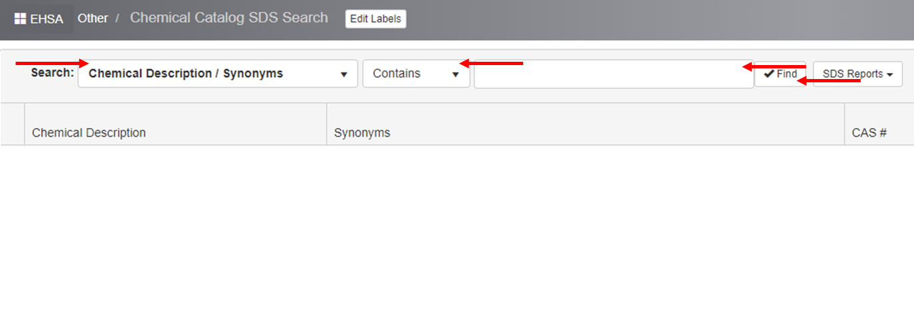

* 1. Type in the chemical name, a chemical component (for mixtures), or something describing it in the box to the right of the search drop-down. You may change the middle drop-down from “contains” to “equals” or “starts with” if you end up having trouble finding what you’re looking for. Hit Find.
  2. Multiple results will likely pop-up. Use the scroll function to see if what you desire is listed. Results will often have CAS# for confirmation, or a description in the *Synonyms* box.
  3. Once the correct substance or item is located, click the yellow drop-down arrow on the left. Underneath a new row will be displayed. If a SDS is available, it will have a date and file listed here.
  4. To view the SDS, simply click this information to highlight the row and then click **View Document**.
  5. To print a system-generated HazCom label, click “SDS Reports” at the top after having highlighted the substance, then click **OSHA Hazard Communication Label**. Information will still need to be manually added if you go this route for the label.
  6. The easiest way to ensure a SDS is linked in the system under the PI permit is to put a link to the electronic SDS website on the chemical inventory form (can also be entered on the quick entry chemical inventory pages- see **section 5**).

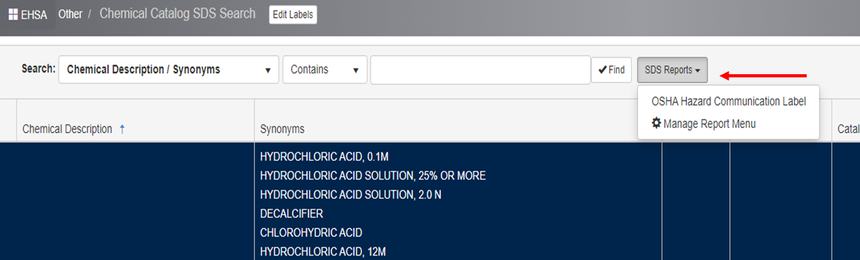

* 1. If the SDS is not available and it **should** be, let EHS know as soon as possible.

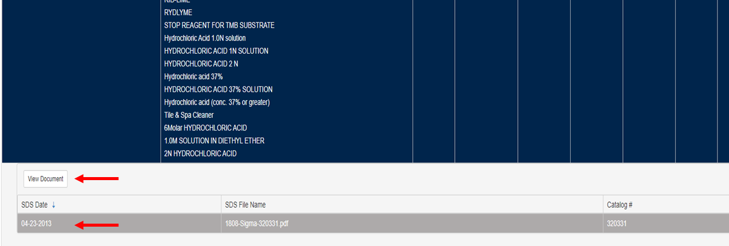

1. **Chemical Inventory** 
   1. Select the ***inventory*** icon on the home screen.

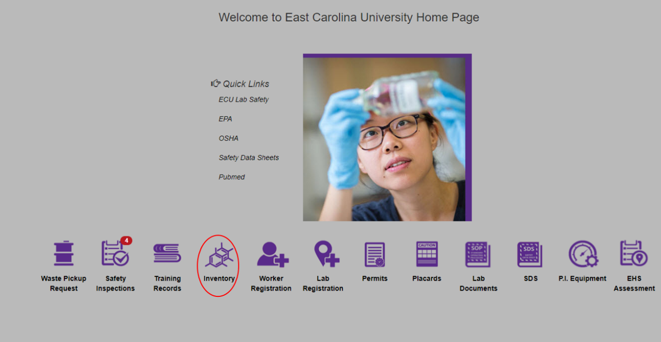

* + 1. Click “*Quick Chemical Entry*” to view, add, edit, or remove chemicals. Ensure the PI is correct.
       1. Add a chemical: click the add button on the top left of the screen

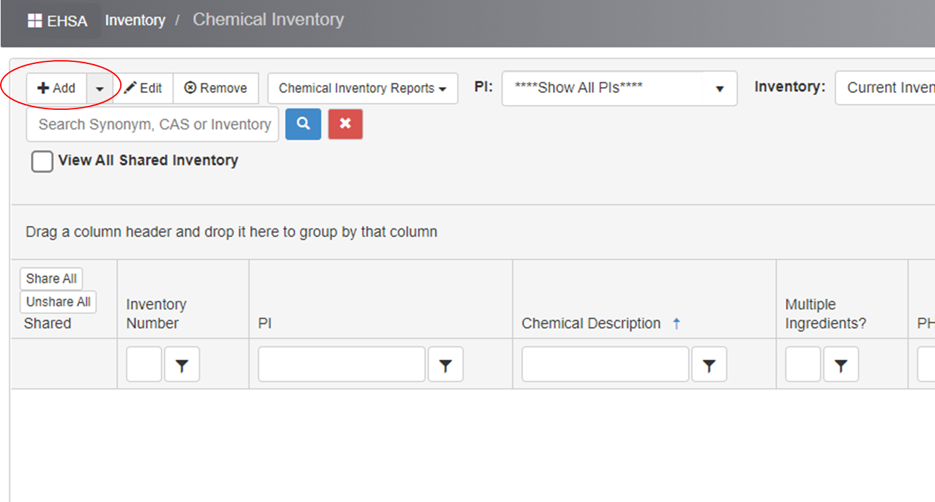

* + - 1. When the pop-up screen appears, you can search for a chemical by its name (description), CAS #, or via your personal catalog if it is uploaded. If the chemical you have typed in shows up below, click “Select.” If the chemical is not there, you can click the “x” in the top right corner of the box to exit out of the pop-up search.

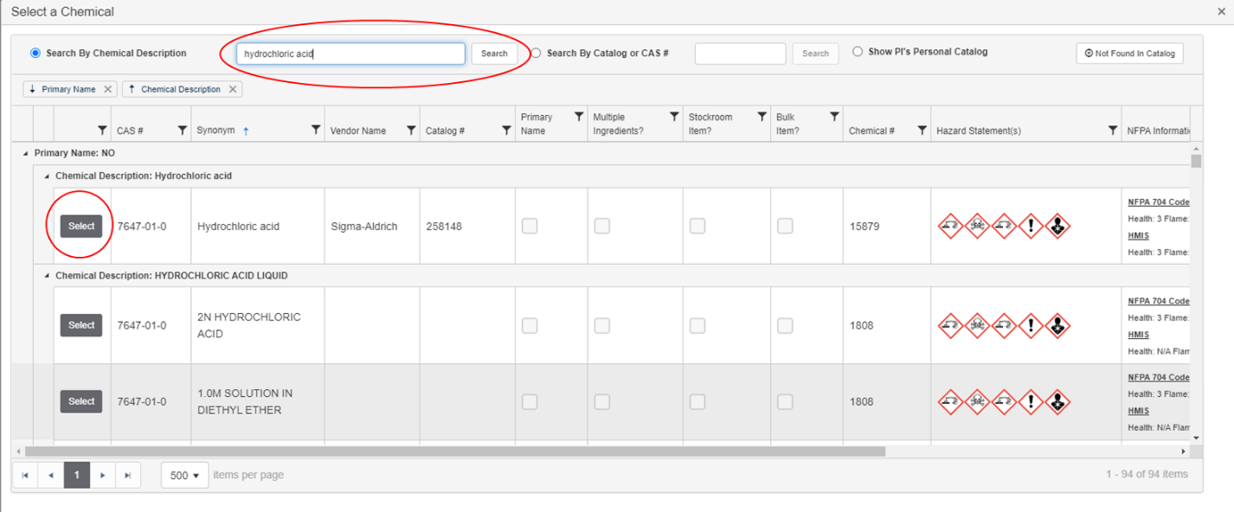

* + - 1. If the chemical is found, the chemical information will automatically populate into the Chemical Information and Hazard Information Box. The only boxes required to be populated are marked with an asterisk. Click “Save.”
      2. If the chemical or substance is NOT in the chemical catalog, type the name into the Chemical Description Box and input the CAS #, if there is one. If no CAS #, leave that box blank. Ensure the “Not in Catalog” bubble is filled. Click “Save.”
      3. Add the URL for the SDS when prompted to do so. It will be the easiest way to ensure the proper SDS is quickly accessible and on-file in the event of an emergency.

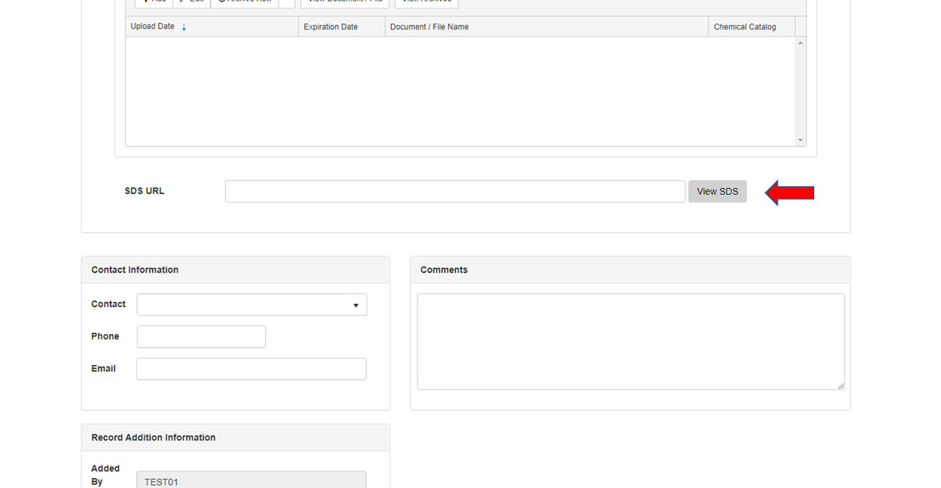

* + 1. Edit or delete a chemical: Click on the “Edit” or “Remove” buttons at the top of the main Chemical Inventory page.
       1. A box will pop-up with the number of items you would like to remove and reason for removal information. To delete more than one item, click on the yellow highlighted boxes under the “*Select For Removal*” category. Click “Remove”.
    2. Features: you can sort by a category. For example, if you want to sort chemicals by lab number. Grab the header of the category you want to sort with, such as “lab/room” and move it to the area that says, “Drag a column header and drop it here to group by that column.”
    3. Review inventory: assuming the PI has been selected in the drop-down on “quick chemical entry”, the inventory should be shown below. Because ECU does not use a scanner system, “*Chemical Inventory Verification*” is not the best option to view the inventory (thought it will work fine for these purposes-image below).

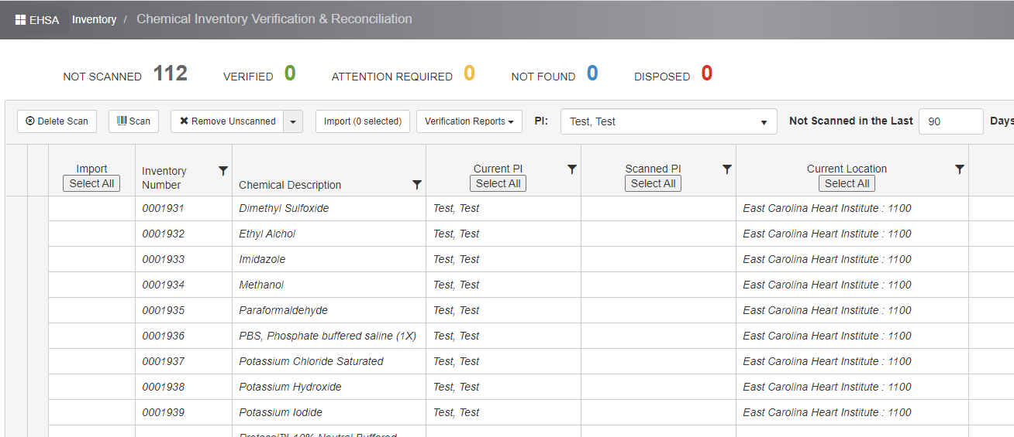

* 1. Annual inventory alert: the system is set to remind the PI to upload or confirm active inventory annually. A red indicator will appear on the **Inventory** icon on the home screen; click the icon. Alternatively, if you were previously on the *Chemical Inventory Verification* page, you can simply click *Inventory* on the top-left to go back one level.
     1. Select “*Chemical Inventory Review Statement*”.
     2. On the right-side of the screen, you will see where you can confirm the chemicals in your inventory are active and up-to-date.

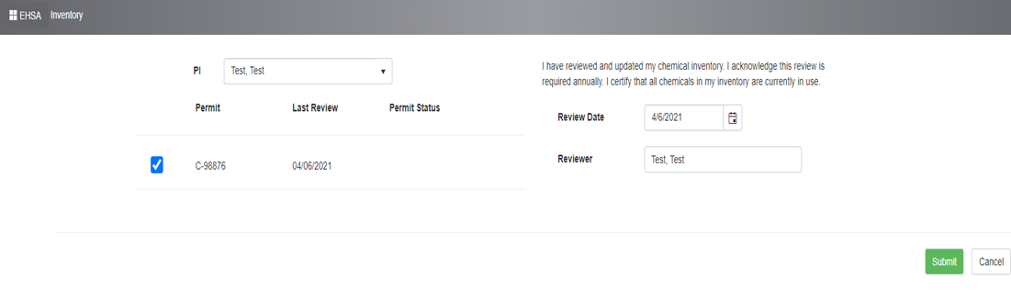

* 1. **Inspections**
     1. Self-Inspections: self-inspections should be performed weekly, semesterly, and annually.
     2. Click the “inspections” tab on the home screen.
     3. Click the “perform self-inspections” link to the left.

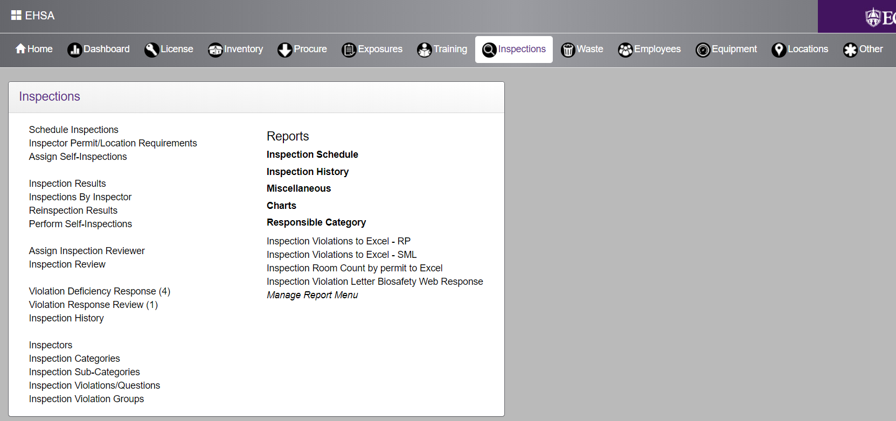

* + 1. Click “Add Self Inspection”.

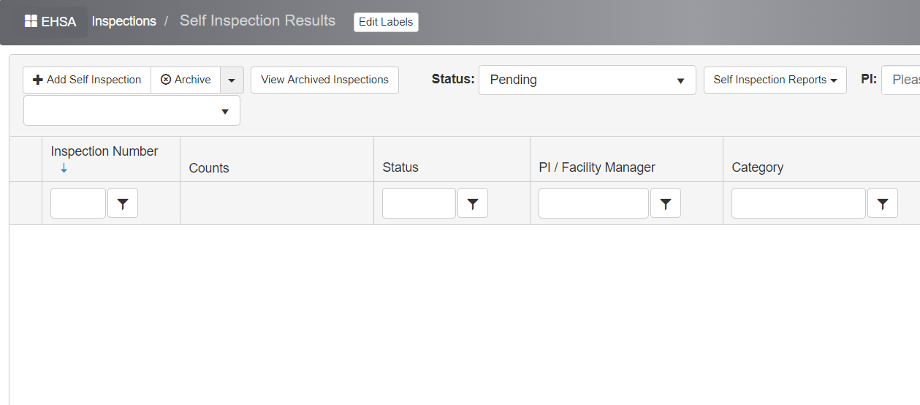

* + 1. For *Category*, choose the drop-down that best fits your need (annual, semester, or weekly). Ensure the correct name is displayed as the individual completing the inspection.
    2. Select the correct PI if the name is not already chosen and then choose the lab for which the inspection applies by clicking “select” next to it. It will add the location to the box to the right.
    3. Once everything looks correct, click “Create Inspection” at the bottom-left of the screen.
    4. Click the “view” drop-down to the left if it is not already displayed with the categories. To draw-up the categories, simply click “hide” (a now red button where “view” was).
    5. For each category, select “yes” or “no”. The selection will be highlighted once clicked (see below).

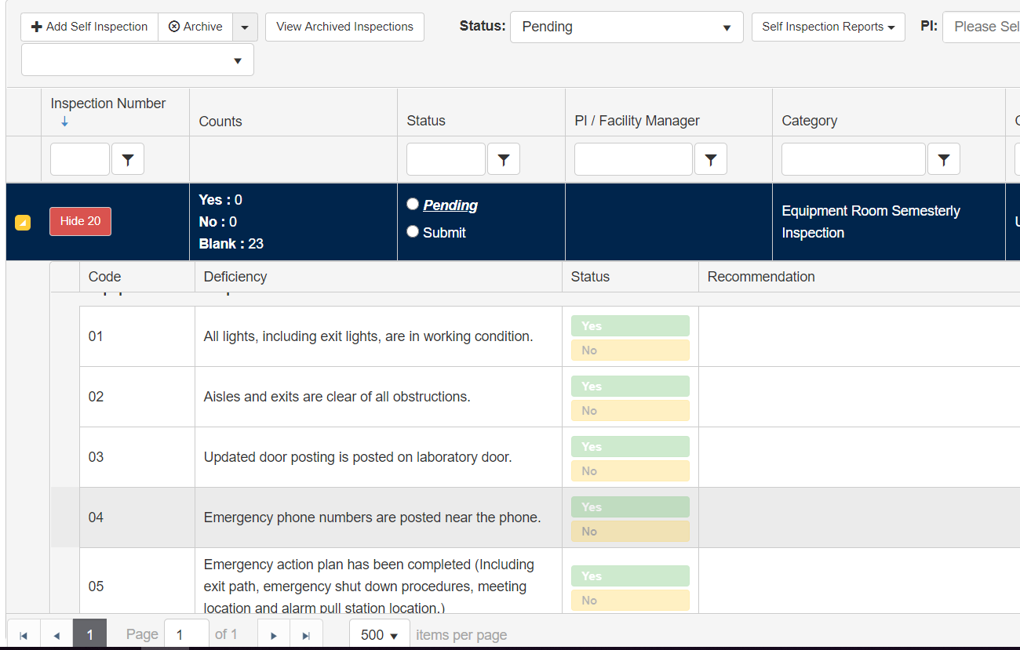

* + 1. Enter observations/notes to the right if issues are present or a plan is in place to fix something.
    2. Once complete, click “submit” at the bottom (do not click “pending”). Task completed.

1. **Responding to Deficiencies in your Safety Inspection Report**
   1. Review your safety assessment and respond to and safety deficiencies noted: Click on the “Safety Inspections” icon.
      1. Click on “Violation Deficiency Response”
      2. Select your PI name.
      3. Click on the Inspection Report # in which you would like to respond to. *NOTE*: the most recent report will be the highest numbered.
      4. Double click on the deficiency in red that you want to address to open the violation/deficiency.
      5. Respond: scroll to the last box on the bottom that says “Please Enter Response to Violation

Deficiency Below.” Be sure to fill out all areas in that section (e.g. correction notes, response

date, corrected by.” Then click “Save.”

*NOTE*: Once you mark a deficiency as corrected, it will no longer show as a deficiency. EH&S will review and you will receive a notification if additional work/response is required.

1. **Lab Hazard Assessment/ “EHS Assessment”**
   1. Access: Click on the “***EHS Assessment***” icon at the bottom-right of the home screen.

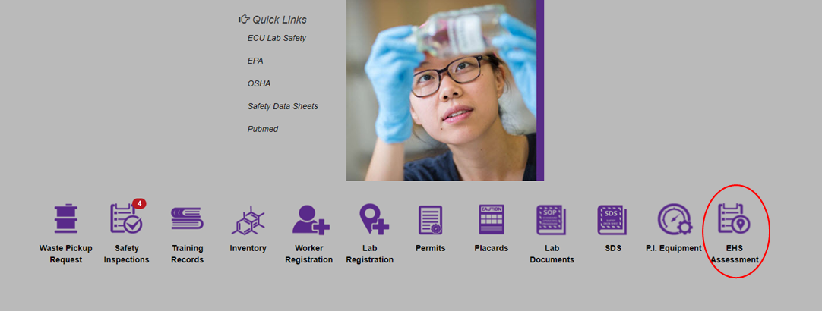

* 1. Click “Browse New Forms” on the left side of the screen, ensuring PI name is correct.
  2. Click the green “Start” button next to “*Lab Hazard Assessment*”. Choose the PI again.

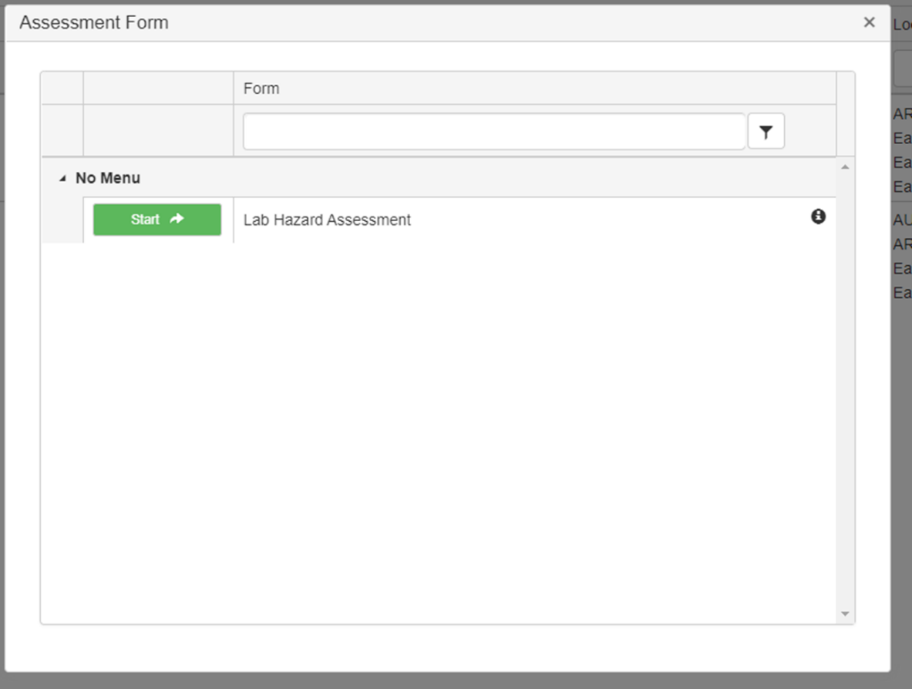

* 1. Select the building(s) and click the green arrow to add them to the attached locations box. Click the X next to an employee or location to remove from the assessment. Click “***Next***” at the bottom to move on to the questions.
  2. Navigate each category by clicking to answer each section to expand specific questions.
  3. Select yes/no for each category as applicable. Please double-click a section to pull-up a description of the category.
  4. Attaching relevant documents: you may attach relevant lab safety plans (LSP) to an answer on the lab hazard assessment as applicable.
     1. Click “manage attachments” to pull up the following screen, then click “add”.

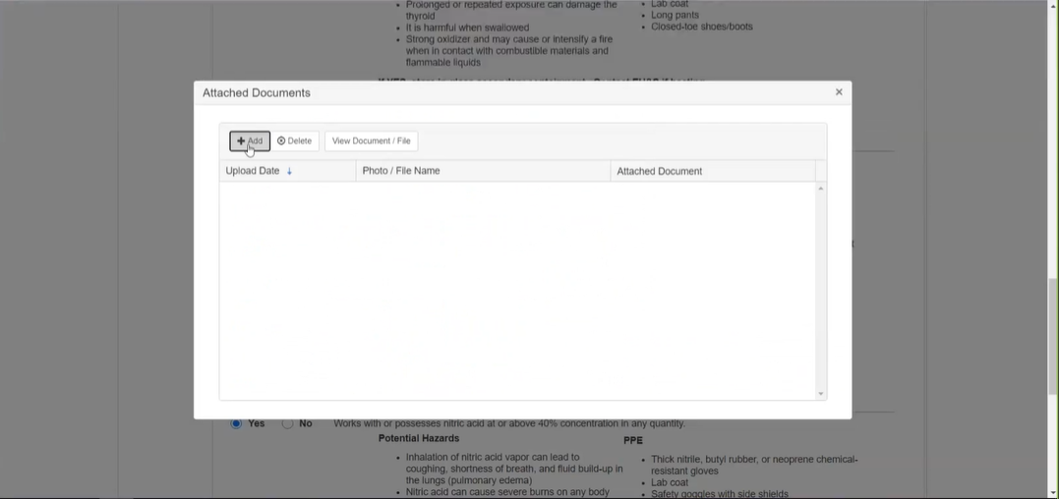

* + 1. Click “Select Document / File for Upload” to open the window to choose your file.

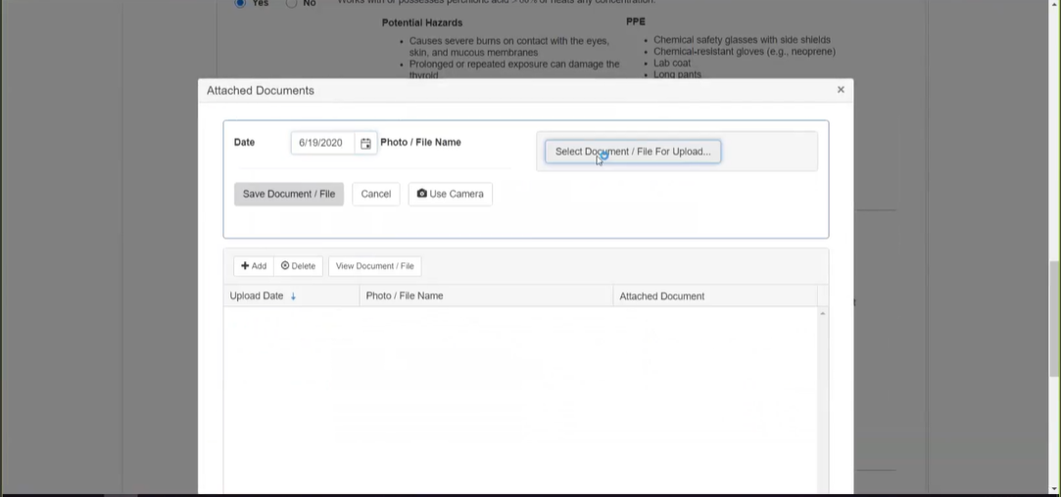

* + 1. Follow the prompts to choose the file desired and you will return to the lab hazard assessment screen.
  1. A location (or an individual in the case of an assigned task) must be selected when “yes” is selected in a category, in order to move forward with marking the assessment “complete”. If not, you will be alerted by seeing a red circle with a number inside next to the category of concern.
  2. Once “complete submission” is chosen, the lab hazard assessment is considered “pending” for EH&S review. It cannot be edited at this point.
     1. If an item is missed/skipped, an alert next to that category will be present to note where you need to answer (red writing will also be shown).

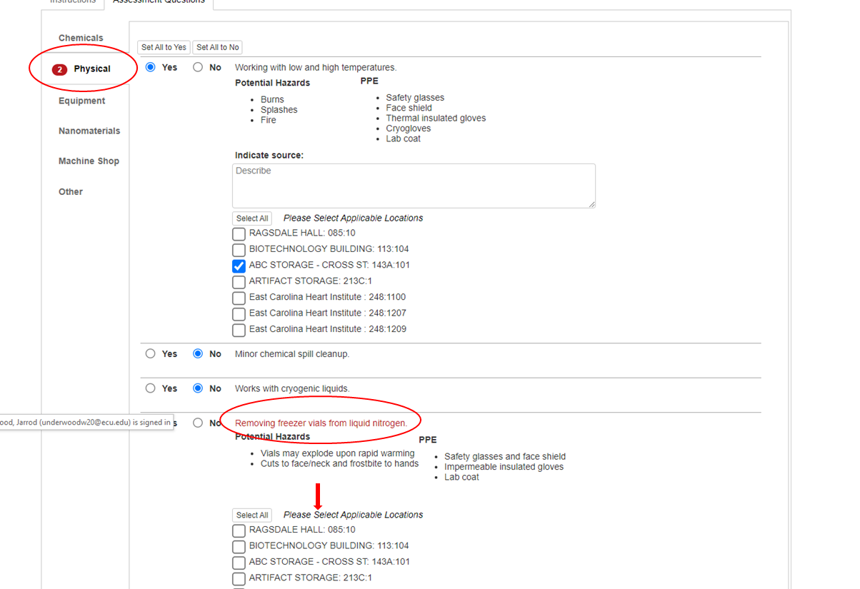

* 1. Once EH&S reviews the submission, comments or questions may or may not be entered into specific categories. Once the review is complete, you will receive an email notifying you of this. Click the link in the email to go straight to the assessment to see what changes may be needed.
  2. If changes are needed, make the changes or enter comments stating otherwise prior to re-submission. If EH&S approves these changes or notes, the status will change from “pending” to “reviewed”. You will receive an email. If this is not approved, the process repeats until approval is reached.

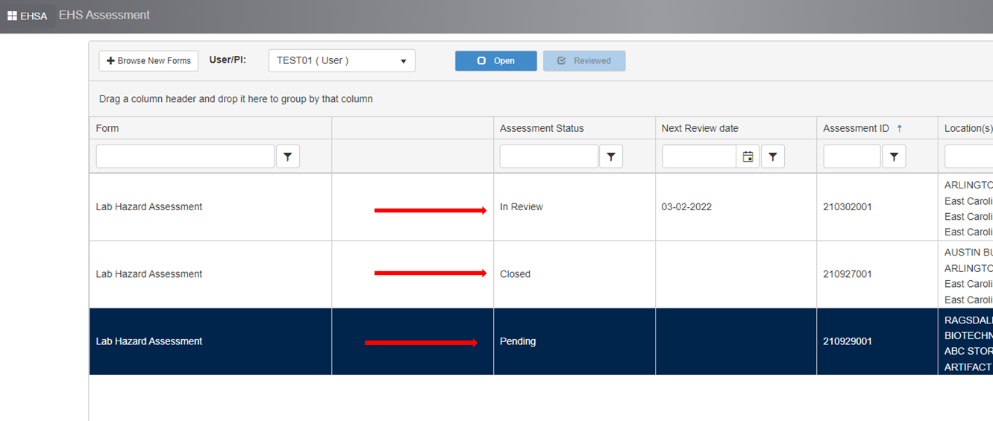

1. **Edit Lab Placards**
   1. Select “***Placards***” icon on the home screen.
      1. Select “Edit Placard Details”
         1. Lab locations under the PI’s permit will appear in list format.
      2. Highlight the lab desired and double-click on it or click the “Edit Lab Placard” button.
      3. Details of the placard are displayed.
   2. *Edit* placard details*.*
      1. Adding contact names/contact numbers (PI, lab manager, staff): select “search all workers” checkbox inside the “location contacts” box.
      2. A search menu will automatically appear. After entering the first few letters of the individual’s last name in the “worker name” box, click “search” to display results.
      3. Results will be listed under “worker name” column; select “attach” button next to the name to add to the placard.
      4. A warning message will appear stating, “This worker currently does not have a Contact Phone #. This worker currently does not have an Emergency Phone #. Please add the required item(s) and click the “Attach” button again.” Click the “OK” button to close the message.
      5. Fill in information for “Contact #” and “Emergency Phone #” and re-click “Attach” button next to the worker’s name.
      6. The contact is now added to the placard. Repeat Steps 2 through 7 to add additional contacts.
      7. Select “Save” at the bottom of the page to save the placard in the database. You may edit placards for other lab rooms by repeating this process.
   3. Review/print the placard.
      1. The information just entered for the placard may now be reviewed and printed. Return to the edit lab placards page (may say “Locations” at top).
      2. Single-click the row corresponding to the lab location you desire. Click the “Reports” drop-down near the top and select “Lab Placard Report”. A PDF format of the door posting will appear in a new tab/window. Note: contact information and hazard icons are represented on the placard. Ensure emergency location information is present. If not, return, and complete before printing.

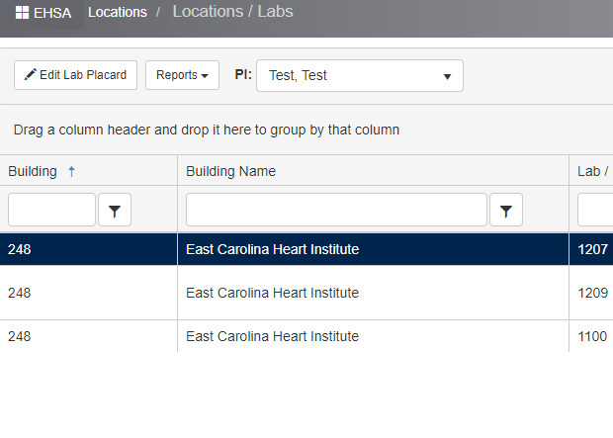

* + 1. To print the placard, click on the printer icon at the top righthand corner. It is recommended to print the placards on cardstock paper.
    2. Once printed, display outside the lab or storeroom in an acrylic door sign holder or plastic sleeve protector.
    3. You may also download the PDF to your workstation or other device.

1. **Waste/Supplies Requests**
   1. Select the ***Waste*** icon on the top row of the home screen. The waste pickup screen appears.
   2. Click the “Waste Pickup Requests” option on the left-most column of the screen.
   3. Waste pick-up requests
      1. Click the “+Add a Waste Request”.

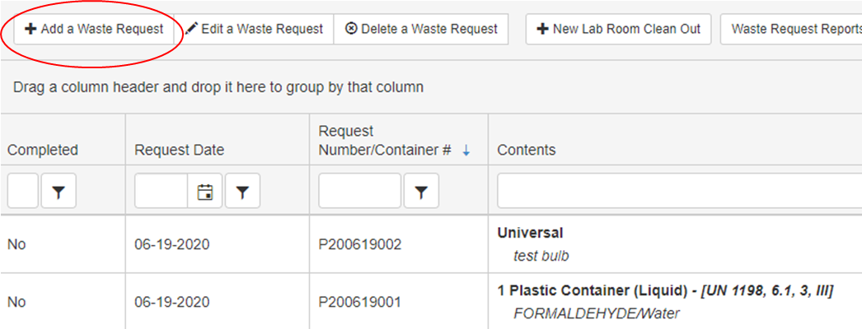

* + 1. At the “Waste Profile” screen, you may: generate a waste request by completing information under Container # and order supplies. Note: please ensure that your Waste Profile displays correct contact and location information.
    2. Ensure that location (building and lab/room number) of the waste is correct under “Waste Profile” box. If not, click “Edit” button to select new building/room number (a pop-up window appears). Click “Save”.

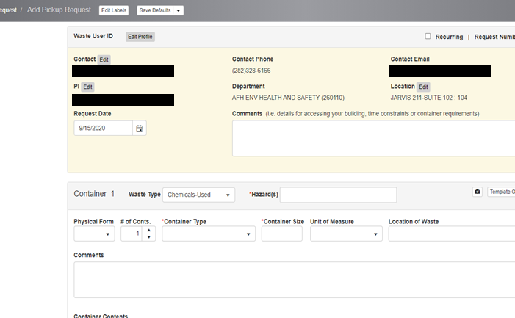

* 1. **Chemical Waste**
     1. Select “Chemicals-Used” in the “Waste Type” field. Highlight/select the Hazard(s) associated by clicking on the hazard from the drop-down list. This will automatically add the hazard to the field. Add as many as needed.
     2. Complete remaining fields (e.g., Container Type, Container Size).
     3. List the contents of the container in “Container Contents” section. Click ***Search*** (under chemical description) to get started; a pop-up window appears (picture below). Enter chemical in “Chemical Description” field and click “Search” to comb the chemical catalog, or enter the CAS # (if known), OR click Browse PI Inventory to locate the chemical.

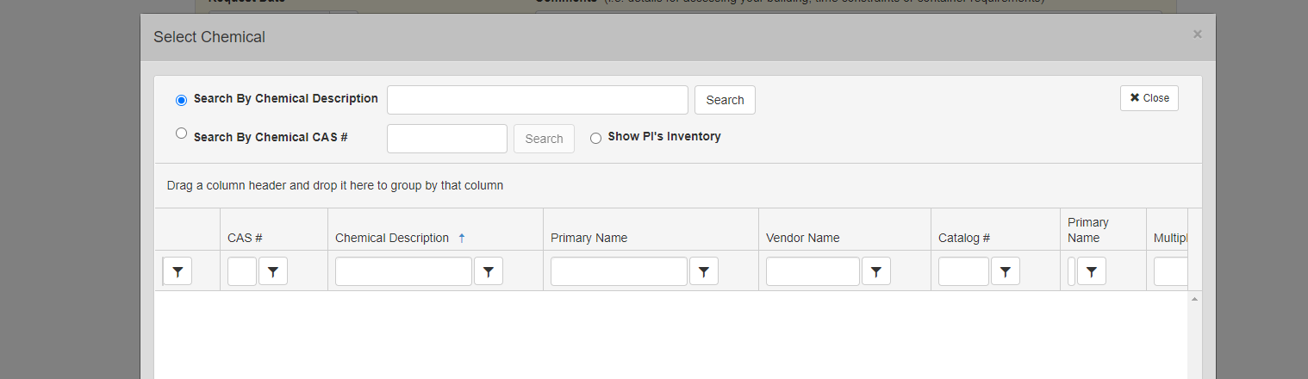

* + 1. Click “Select” to add chemical to the “Container Contents” table. Add additional chemicals to the table as needed to document container contents. Adjust percentages under “% of Content” column for each item added.
    2. If additional containers are needed, click “Add Container” button and repeat Steps 1 to 4. Otherwise, click “Save” button to add request.
  1. **Universal Waste**
     1. Select “Universal” in the “Waste Type” field.

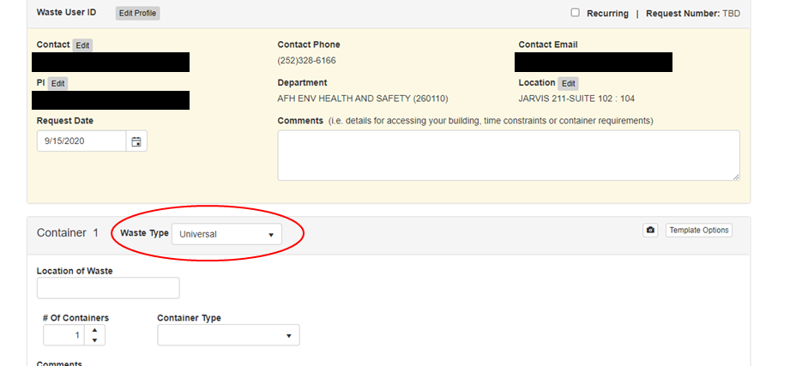

* + 1. Complete remaining fields (e.g., Location, Container Type, Container Size) applicable, or enter a comment. You may take a picture using the camera icon if desired.

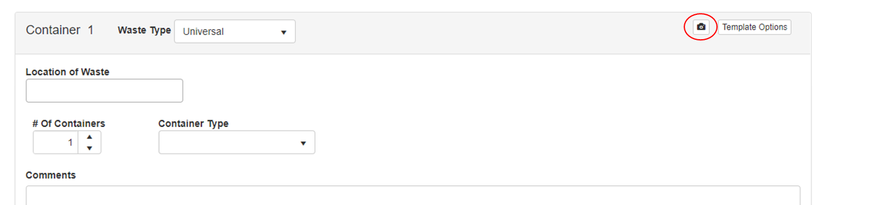

* + 1. Click the field below “Description” of the “Container Contents” table to add universal waste items. Add additional items to the table as needed.
    2. Click “Save” to add the request, or “Add Additional Container” if necessary to add to the request.
    3. The same process can be completed for unknown waste; by choosing “unknown” where “universal” was selected.
  1. **Print Hazardous Waste Labels**
     1. Select the waste pickup for which you would like to print a hazardous waste label by clicking on the row.
     2. Select “Waste Request Reports” and select “Chemical Waste Label_ECU” from the drop-down.

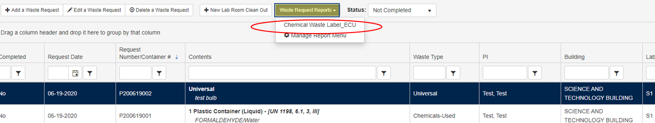

* + 1. The hazardous waste label will pop-up as a report where you will have the option to print the label, following the instructions for displaying it on your waste container. You may have to turn the pop-up blocker off to complete this step, or manually mark the page for an exception to allow.
  1. **Request Waste Pickups**
     1. At the “Waste Request” screen, click on the “Request Pickup” button for the waste item created.

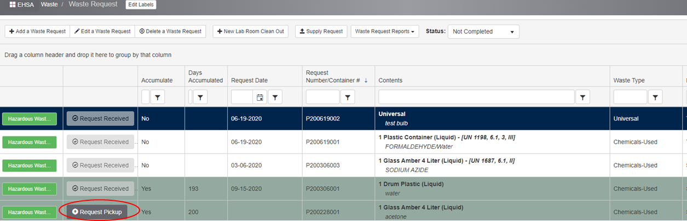

* + 1. A “Confirm” pop-up window will appear. Click “Yes” button to initiate request notification email.
    2. The “Request Pickup” button will change to a greyed out “Request Received” banner.
    3. Repeat Steps 1 to 3 for all waste items created.
  1. **Order Replacement Containers/Supplies**
     1. On the home screen, click the “Waste/Lab Supplies” icon (below). Click “+Add” to initiate a new request

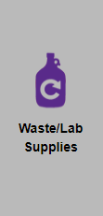

* + 1. Click the “Building” field to reveal a drop-down. Type in the building name or scroll using arrows.
    2. Click the “Lab” field and select the appropriate room from the drop-down menu.

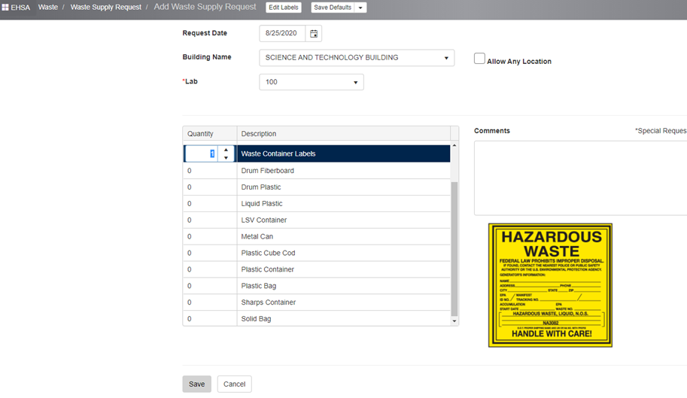

* + 1. Select item quantity by entering a value (or using up/down arrows). Insert instructions in “Comments” box as needed (e.g., “…*please provide both adhesive and tie-tag labels*”).
    2. Click “Save” to dispatch a request notification email and save the request.
    3. An automated email will be sent alerting of the request.

1. **Technical Issues**
   1. Surface Pro Tablets
      1. If your camera seems stuck in a position, such as “selfie” position, change the settings for optimal inspection response and documentation.
      2. Bring up the camera (“use camera”) during the task. 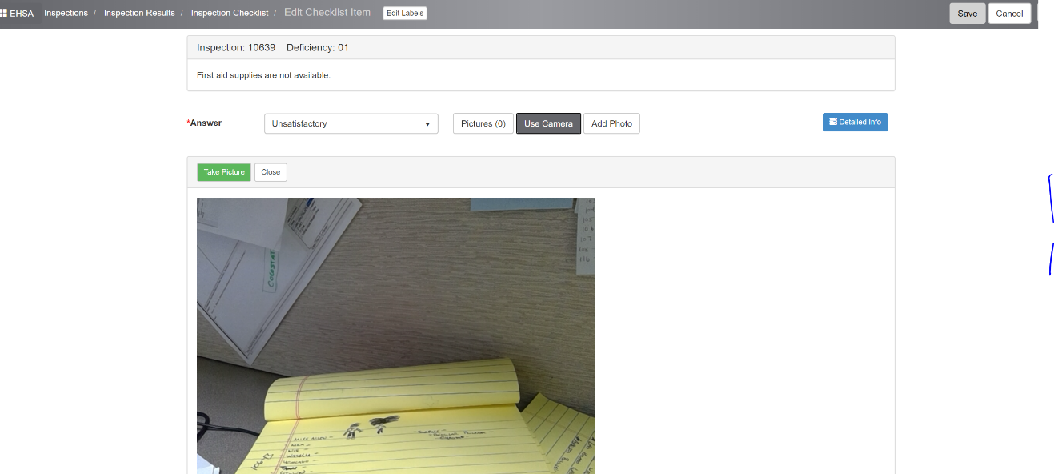
      3. Click on the camera icon on the toolbar. Click “manage” to get to camera settings.

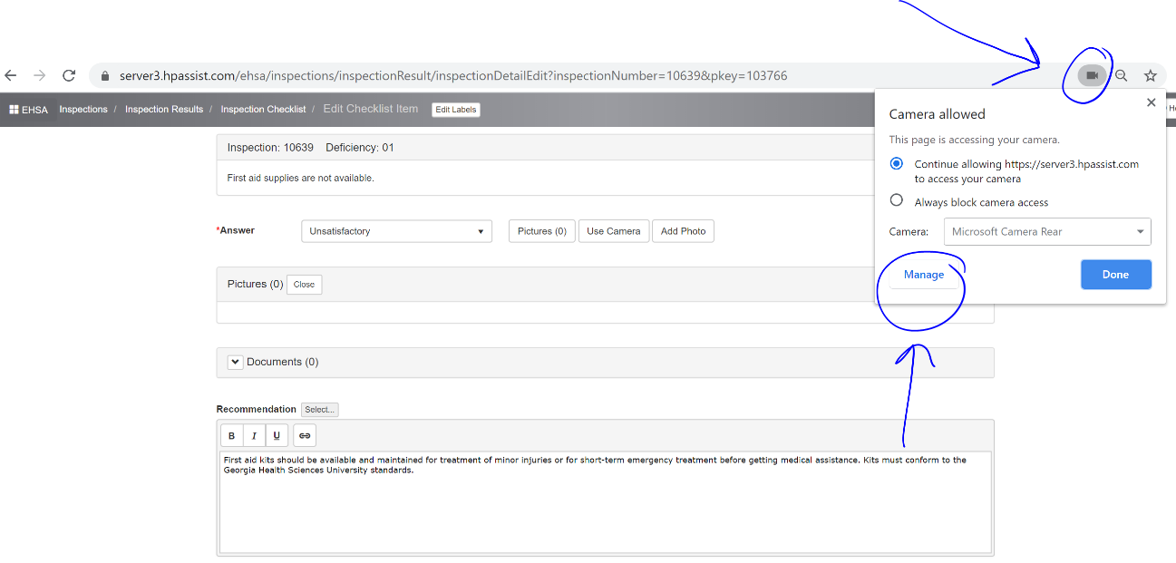

* + 1. Select “rear-facing” camera option.

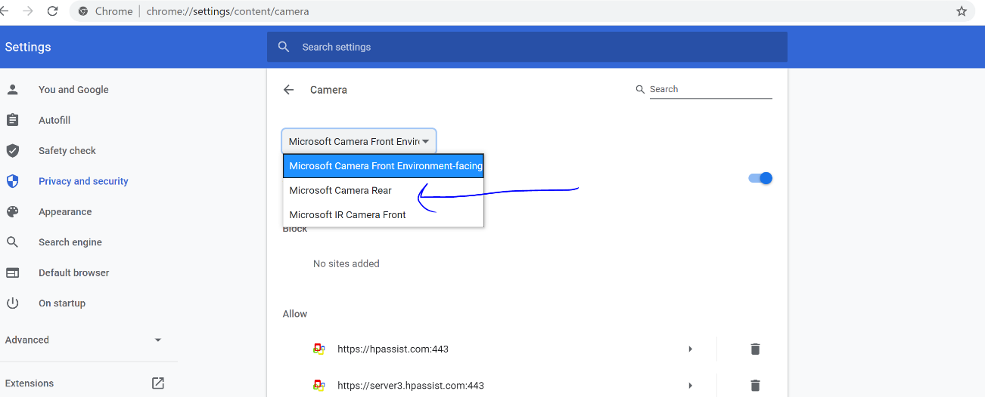

* + 1. You may need to log out and log back in for settings to take effect. It should default to the new settings from then on.